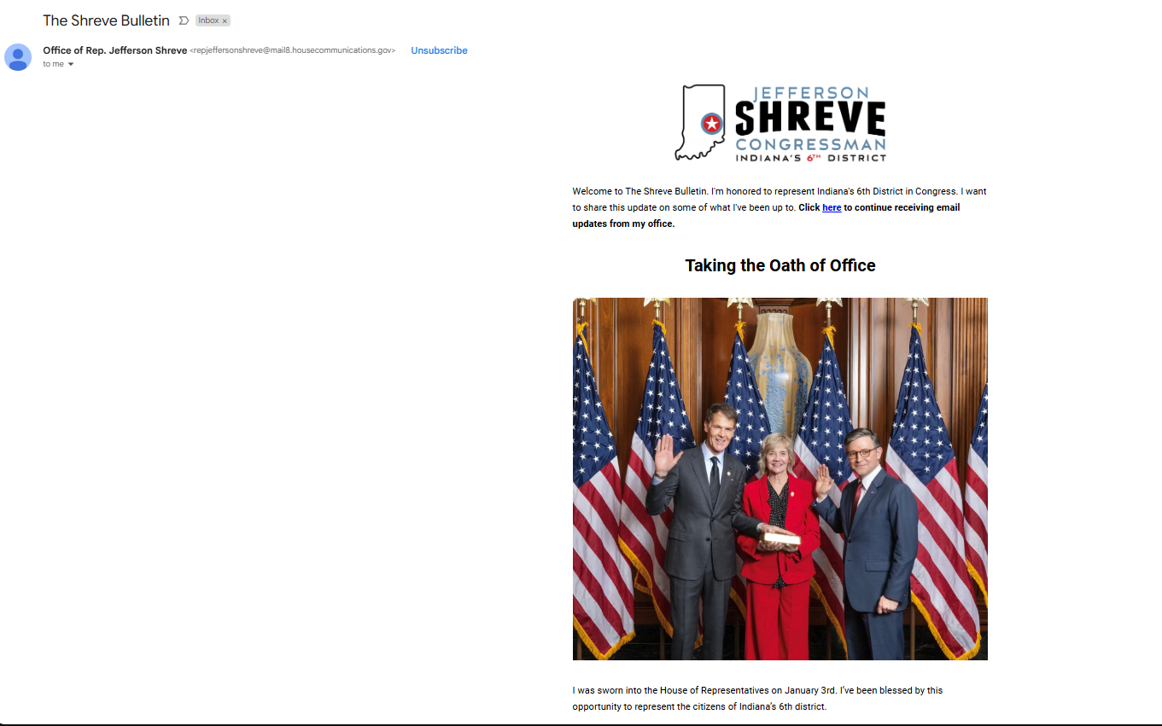

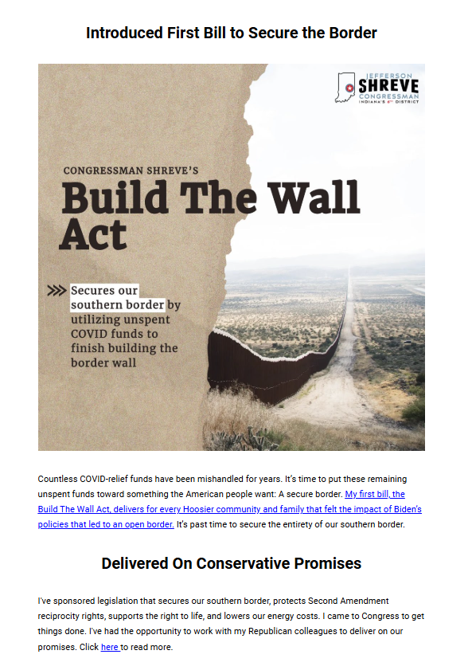
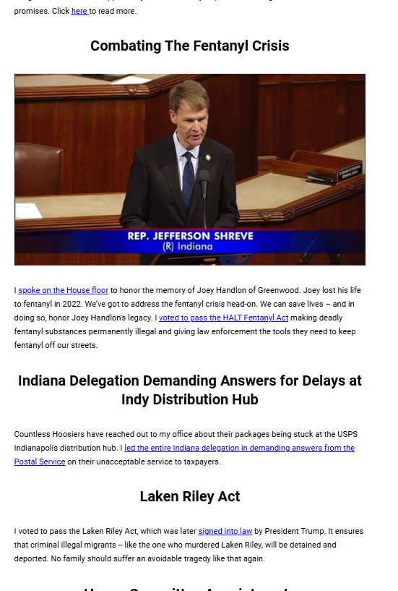



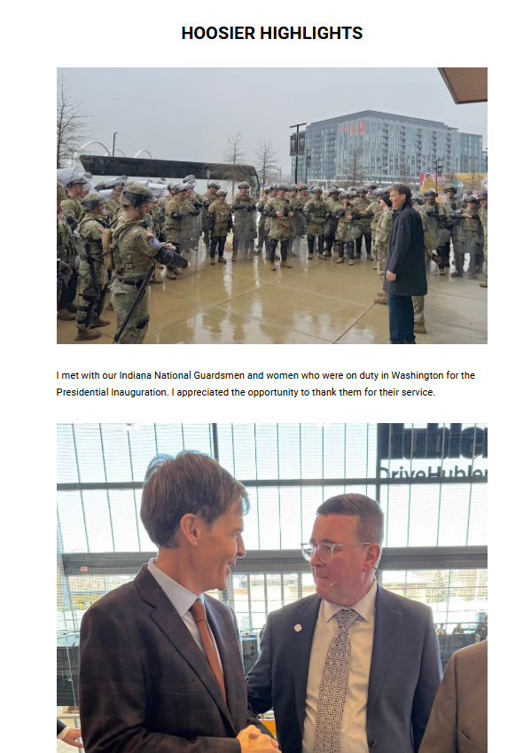

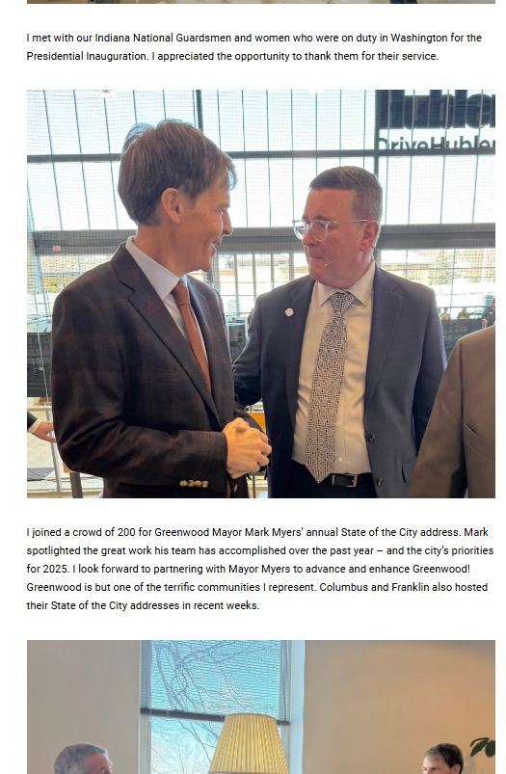

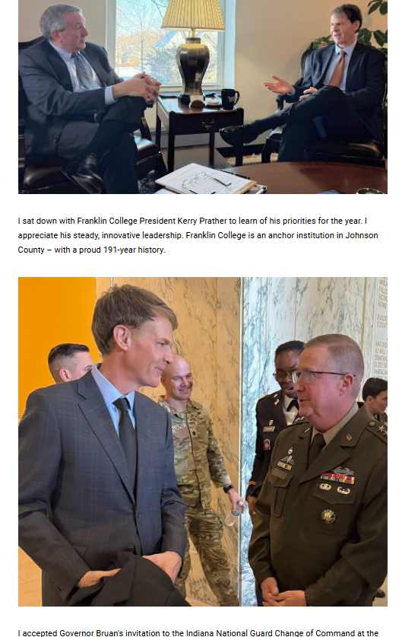

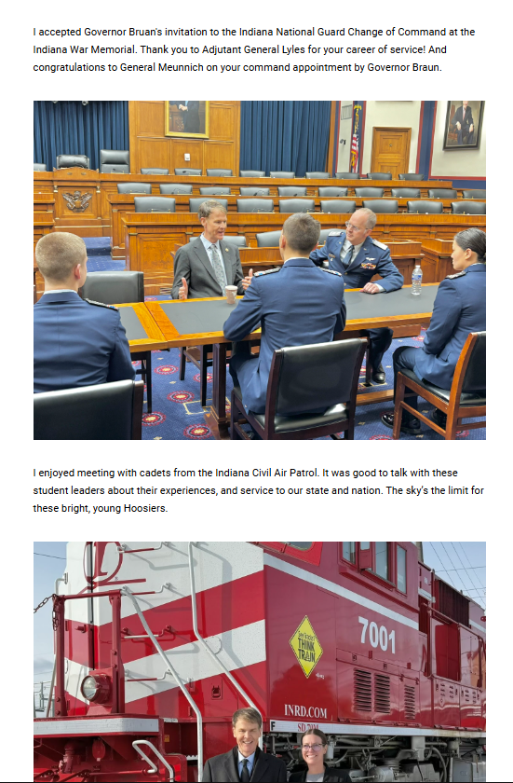

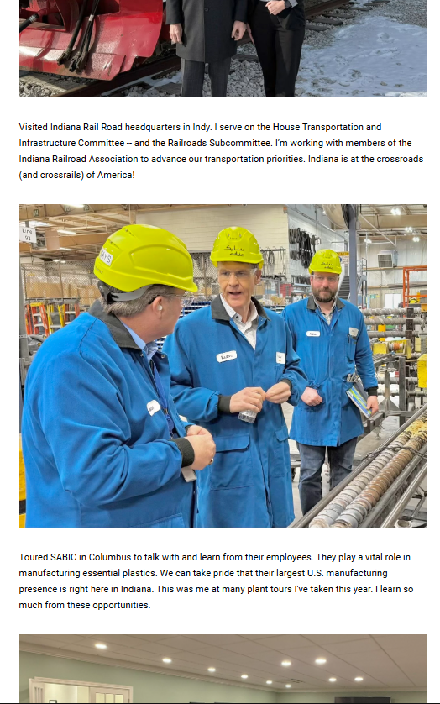

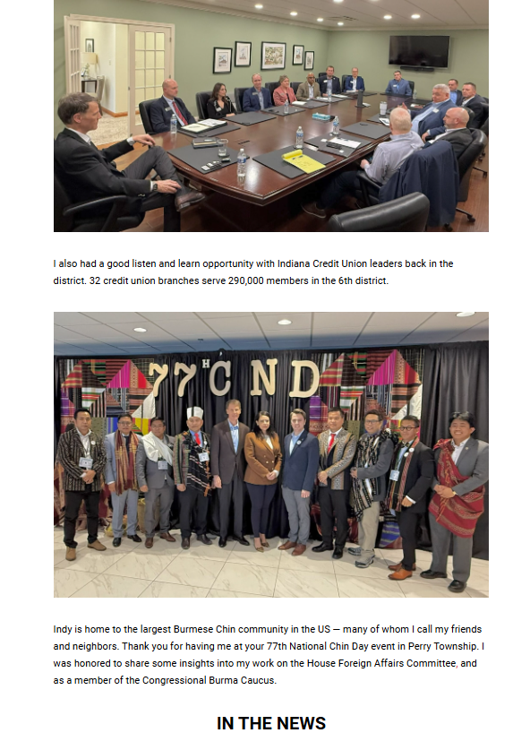

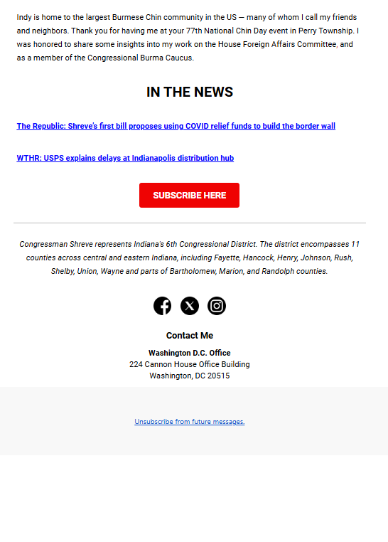

Links in order of appearance on Newsletter:

https://shreve.house.gov/contact/newsletter-subscribe
https://shreve.house.gov/media/press-releases/shreve-introduces-first-bill-congress-finish-building-southern-border-wall
https://shreve.house.gov/media/press-releases/congressman-shreve-delivers-conservative-promise-first-weeks-new-congress
https://www.youtube.com/watch?v=ha16JdTwRm4
https://shreve.house.gov/media/press-releases/after-passing-halt-fentanyl-act-congressman-shreve-honors-life-lost-fentanyl
https://shreve.house.gov/media/press-releases/responding-constituent-concerns-shreve-leads-indiana-delegation-demanding-usps
https://www.foxnews.com/politics/trump-signs-laken-riley-act-law-first-legislative-victory-new-administration
https://shreve.house.gov/media/press-releases/rep-jefferson-shreve-announces-house-committee-appointments
https://www.therepublic.com/2025/02/04/shreves-first-bill-proposes-using-covid-relief-funds-to-build-the-border-wall/
https://www.wthr.com/article/news/local/usps-addresses-delays-at-indianapolis-distribution-hub-indy-brookville-road-jefferson-shreve-united-states-postal-service-post-office-shipping-package/531-e086f7dd-b55f-49a4-8389-ab765c0c385d
Red Button: https://shreve.house.gov/contact/newsletter-subscribe

