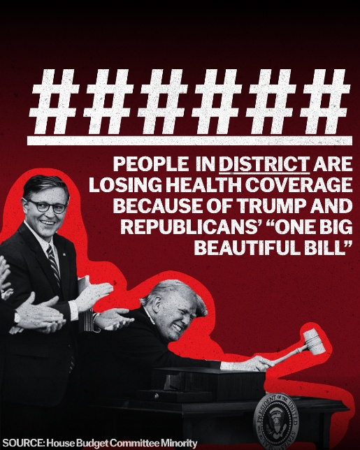
DIGITAL AD

Access Canva template here, use House Budget Committee Democrats microsite to personalize.

Social Copy

On July 4, 2025, Donald Trump signed the “One Big Beautiful Bill” into law.

This bill gutted Americans’ health care and ripped food from hungry families all to prioritize tax handouts for the ultra-wealthy and big corporations.

Thanks to Republican policies like the “One Big Beautiful Bill,” the cost of everything from gas to groceries is skyrocketing. According to House Budget Committee Democrats, here in [DISTRICT], [NUMBER] have lost their health care and premiums have skyrocketed for [NUMBER].

Their signature legislation has done nothing to address the high cost of living that is crushing hardworking Americans.

I want to hear from you: Have your costs increased since the passage of Trump and Republicans’ “One Big Beautiful Bill” last year?

[LINK TO SURVEY]

Survey Text
I want to hear from you: Have your costs increased since the passage of Trump and Republicans’ “One Big Beautiful Bill” last year?

- Yes
- No

By responding to this survey, you opt in to receiving newsletters, texts, and robocalls from my office.

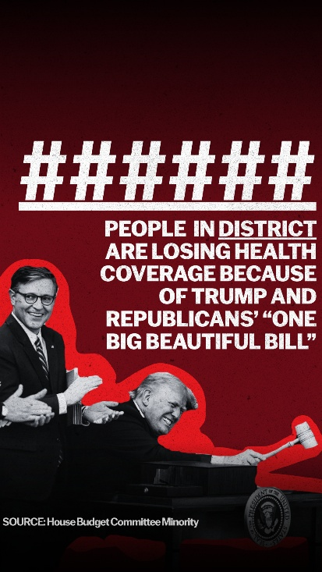
DIGITAL AD – STORY

Access Canva template here, use House Budget Committee Democrats microsite to personalize.

Survey Text
I want to hear from you: Have your costs increased since the passage of Trump and Republicans’ “One Big Beautiful Bill” last year?

- Yes
- No

By responding to this survey, you opt in to receiving newsletters, texts, and robocalls from my office.

