https://youtu.be/nwlxzY3yx_g

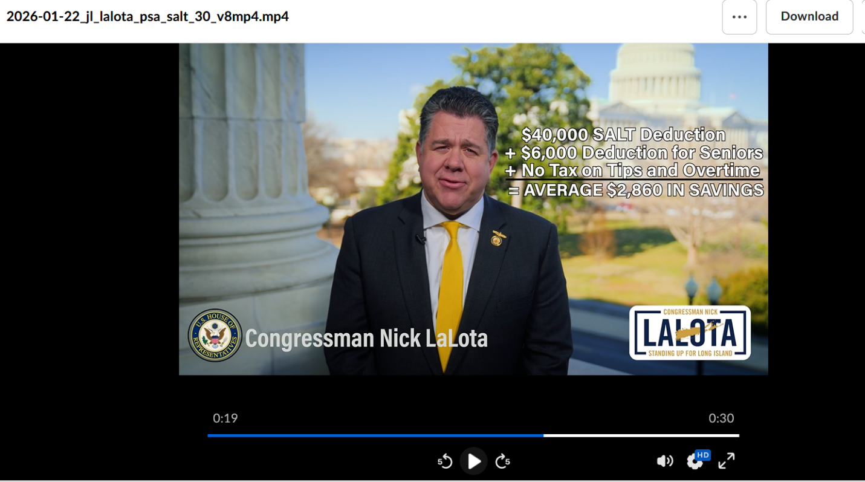

Hey, it’s Congressman Nick LaLota. | DTC
As you file your federal taxes this year, be sure to claim as much of the new $40,000 SALT deduction—and the reduced taxes on Social Security, tips, and overtime—as you’re eligible for under the federal tax code I helped enact. | DTC
These tax cuts are saving the average Long Island family Two Thousand Eight Hundred and Sixty Dollars, compared to what you paid last year. | NL TALKING SPLIT SCREEN OR WHATEVER IS BEST W/ Newsday coverage of $2,860
 | Disclaimer / LaLota Gov Logo

Disclaimer: “Paid for by official funds authorized by the House of Representatives.”

